

**Experiment No. – 3**

**Student Name:** ANIKET KUMAR **UID:** 20BCS5306

**Branch:** CSE **Section/Group:** 20BCS_WM-703 / B

**Semester:** 5th **Date of Performance:** 06th Sep, 2022

**Subject Name:** Machine Learning Lab **Subject Code:** 20CSP-317

# Aim/Overview of the practical:

Implement Linear Regression.

# Apparatus/Simulatorused:

* Jupyter Notebook/GoogleCollab
* Python
* Pand as Library
* Seaborn Library
* Standard Dataset



# Code and Output:

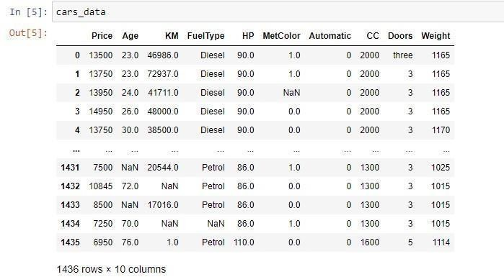

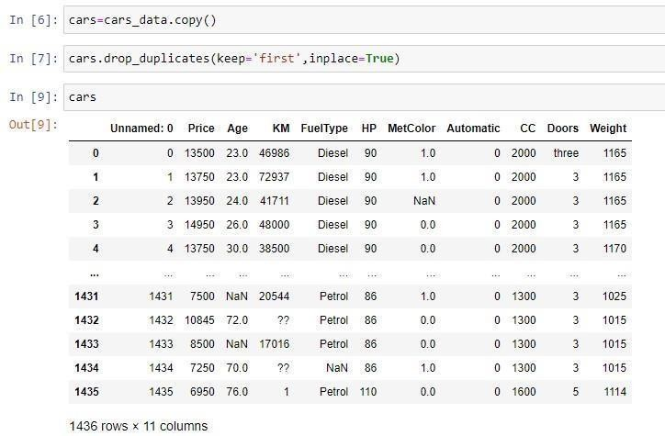

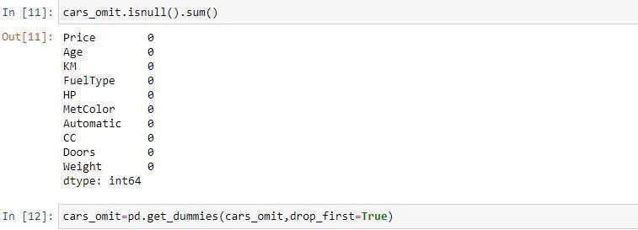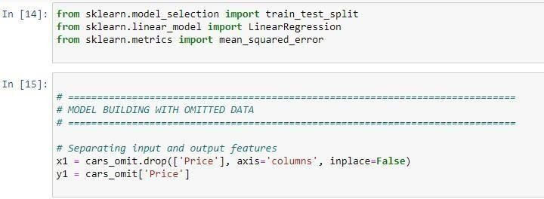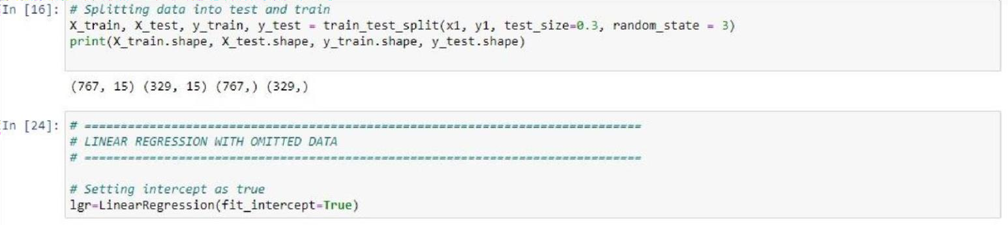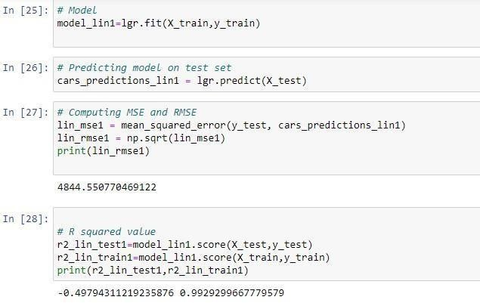

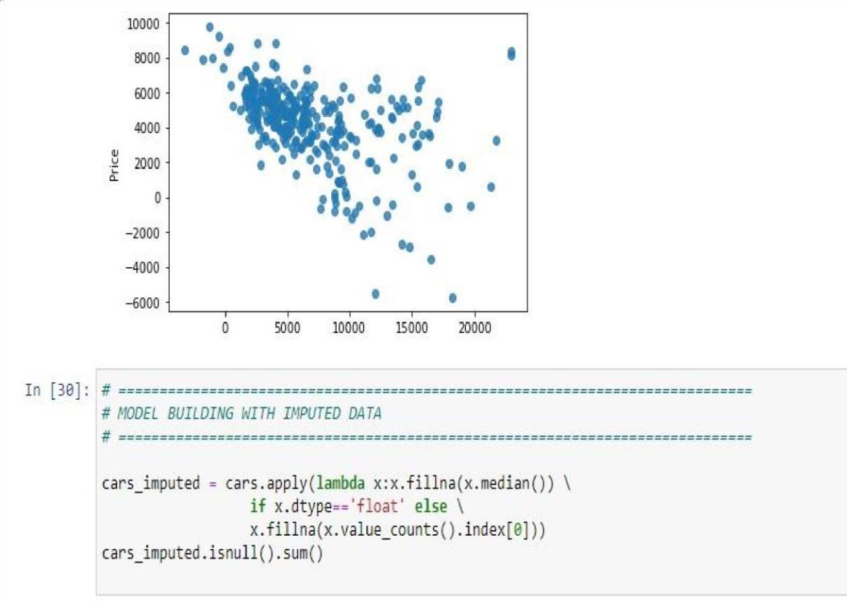

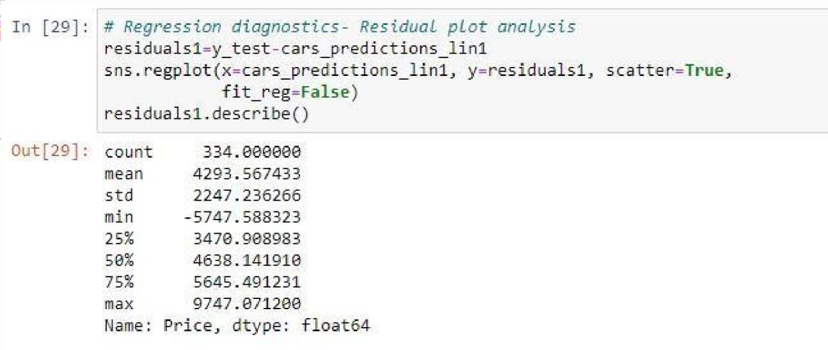

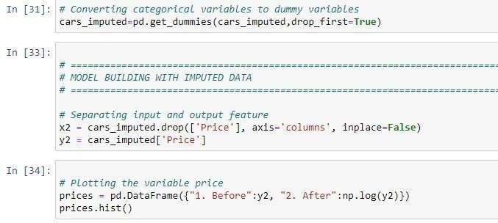

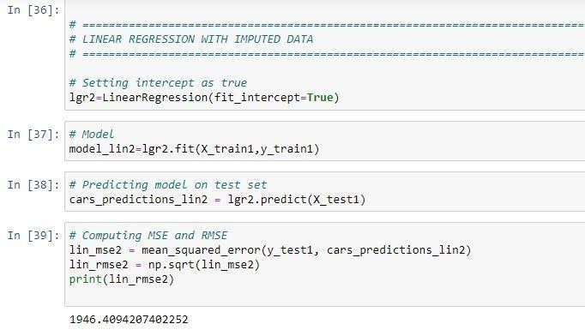

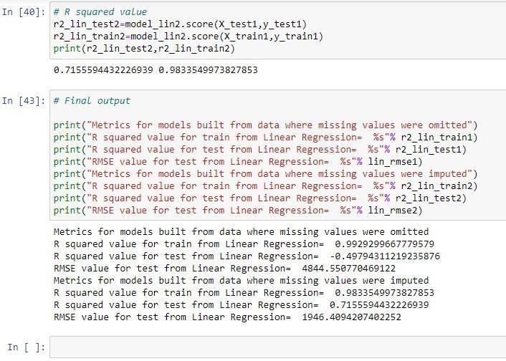

**Evaluation Grid(To be created as per the SOP and Assessment guidelines by the faculty):**

|  |  |  |  |
| --- | --- | --- | --- |
| Sr. No. | Parameters | Marks Obtained | Maximum Marks |
| 1. |  |  |  |
| 2. |  |  |  |
| 3. |  |  |  |
|  |  |  |  |